ASSIGNMENT 28

Name : Akanksha Joshi

Roll No : B038

Batch : 3

Div : BTech CS B

--------------------------------------------------------------------------------------------------------------------------

Q.At an airport, a traveler is allowed entry into the ﬂight only if he clears the following

checks:

1.Baggage Check

2.Immigration Check

3.Security Check

The logic for the check methods are given below:

check_baggage (baggage_weight)

•returns True if

baggage_weight

is greater than or equal to 0 and less than or equal to 40. Otherwise returns

False.

check_immigration (expiry_year)

•returns True if

expiry_year

is greater than or equal to 2001 and less than or equal to 2025. Otherwise returns

False.

check_security(noc_status)

•returns True if

noc_status

is &#39;valid&#39; or &#39;VALID&#39;, for all other values return False.

traveler()

•Initialize the traveler Id and traveler name and invoke the functions

check_baggage(), check_immigration() and

check_security() by passing required arguments.

•Refer the table below for values of arguments.

•If all values of check_baggage(), check_immigration() and check_security() are

true,

display traveler_id and traveler_name

display &quot;Allow Traveler to ﬂy!&quot;

Otherwise,

display traveler_id and traveler_name

display &quot;Detain Traveler for Re-checking!“

Invoke the traveler() function.

Modify the values of diﬀerent variables in traveler() function and observe the output.

Source Code

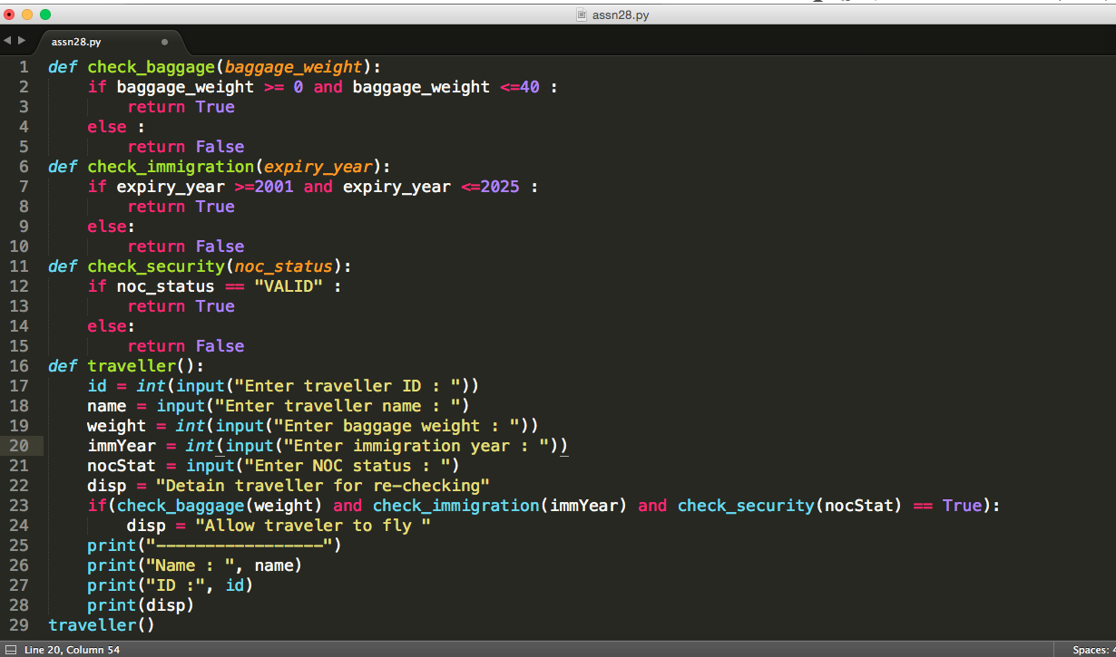

Output

Enter traveller ID : 121

Enter traveller name : Kruttika

Enter baggage weight : 30

Enter immigration year : 2019

Enter NOC status : VALID

-----------------

Name : Kruttika

ID : 121

Allow traveler to fly